Kinematics Review Quiz Multiple Choice Questions

1. Which of the following are VECTOR quantities?
I. position II. speed III. displacement IV. velocity
a. I and III only d. II, III and IV only
b. III and IV only e. I, III and IV only
c. I and IV only

2. Two hikers set out from the same spot and arrive at the same destination but they take different routes. Which of the following quantities must be the same for both hikers?
a. | distance | d. | average speed
b. | displacement | e. | acceleration
c. | average velocity

3. Which of the following graph(s) does(do) NOT represent uniform motion?
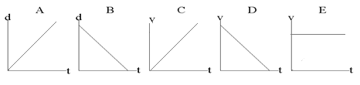

a. | A,B,C and D | d. | A and B
b. | B only | e. | C and D
c. | E only

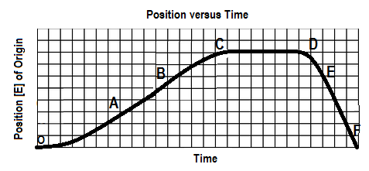
4. The graph below shows a position-time graph

Over which interval is the object moving west and speeding up?
a. OA b. BC c.CD d. DE e.EF

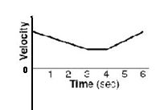

5. A velocity-time graph is shown at right. Which of following best describes the
object’s motion? The object

a. moves backward at a constant velocity, stops, then moves forward at constant velocity.
b. moves forward at a constant velocity, stops, then moves backward at constant velocity
c. slows down uniformly as it moves backward, stops, then speeds up uniformly as it moves forward
d. slows down uniformly as it moves forward, continues at a constant velocity forward, then speeds up
uniformly as it continues to move forward
e. slows down uniformly as it moves backward, continues at a constant velocity backward, then speeds
up uniformly as it moves forward

6. The slope of a line drawn tangent to a curved position-time graph represents
a. | displacement | d. | acceleration
b. | instantaneous velocity | e. | distance
c. | average velocity

7. An object is travelling west and slowing down. The directions associated with the
object’s velocity and acceleration, respectively, are:
a. [W], [W] b. [W], [S] c. [W], [E] d. [E], [W] e. [E], [S]

8. The area under a velocity-time graph represents
a. | displacement | d. | instantaneous velocity
b. | acceleration | e. | average velocity
c. | change in velocity

SPH4U0-Feb 2018 Kinematics Review Quest- Name:_________________
Total: _________/36 marks [K/U]
Useful Equations and Constants:
v_{av} =ΔΔ a =ΔΔ = Δ Δd= ½ (v₁+v₂) Δt Δd=v₂ Δt – ½ a (Δt)²

Δd=v₁ Δt + ½ a (Δt)² Δd = $\frac{v22-v12}{2a}$ g= 9.80 m/s²

Part A: Multiple Choice Answers [ 8 marks]:
Write the letter representing the best answer for each question in the table below:
1 | 2 | 3 | 4 | 5 | 6 | 7 | 8

Part B: Short Answer and Problem Solving [ 20 marks]:

1. Does a car's speedometer indicate average speed or instantaneous speed? Explain. [1]

2. Is it possible for an object to have zero velocity but non-zero speed after moving over a given time
interval? If the answer is “no”, explain why this is impossible. If the answer is “yes” give an example
to support your explanation. [1]

3. A bobsled team competing in the 2018 Winter Olympics starts their run with an initial velocity of
15.0 m/s [Forward]. If they accelerate at a rate of 1.25 m/s²[Forward], find their velocity and displacement
after the first 10.0 seconds of their run. [5]

4. A toy rocket is launched from rest and rises for 10.0 seconds with an acceleration of 2.25 m/s² [up]. After 10.0s, the fuel runs out and the rocket begins to slow down due to the downward acceleration of gravity. It reaches a peak height and then falls back down to Earth.
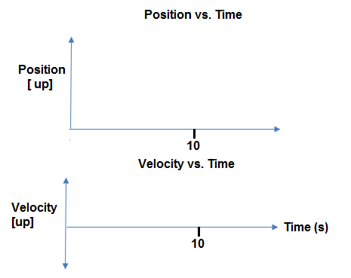
- Sketch the position-time and velocity-time graphs of the rocket from its launch to the peak height. [2]

- Find the velocity and displacement of the rocket after the first 10.0 seconds. [3]

- Find the total time the rocket is in the air and the peak height reached above ground. [3]

5. Two speed skaters are competing in a practice race. Simren (S) is very skilled and can skate at a constant speed of 14.0 m/s [F]. She is competing against Paramveer (P) who is new to the sport. Paramveer can skate at a constant speed of 11.8 m/s [F]. They line up on the start line and Simren gives Paramveer a 2.00 second head start before pursuing him.
- Which graph below correctly represents their motions? (Circle your choice) [1]
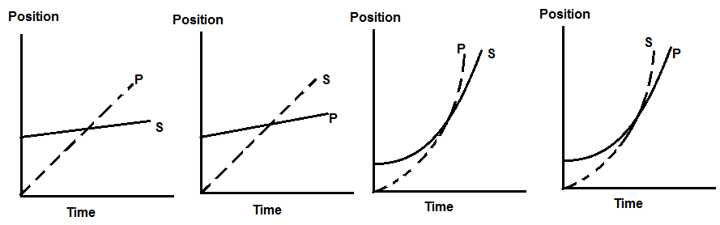

- Find the time it takes Simren to catch up with Paramveer and the position from the start line at which she catches him. [4]

Part C: Graph Analysis [8 marks]

1. The motion of a train engine moving along a straight track in a railyard is shown on the velocity-time
graph below.
i) Draw the corresponding acceleration-tine graph for the train. [3]
ii) Assuming that the train starts at the station (origin), draw the corresponding
position-time graph. [5]

Position-Time Graph:

Velocity-Time Graph:
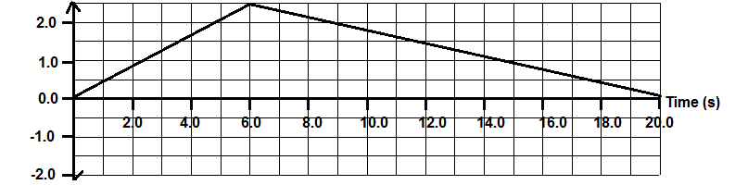

Acceleration-Time Graph:

